**Data Cleaning**

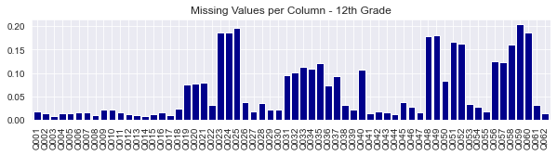

Data Cleaning - Missing Values per Column - 12th Grade

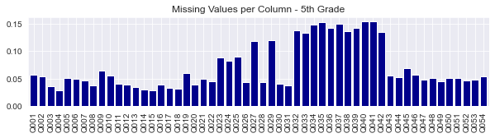

Data Cleaning - Missing Values per Column - 5th Grade

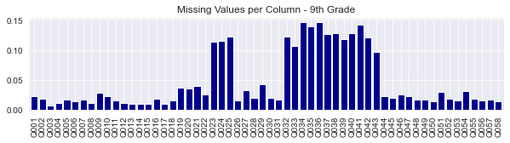

Data Cleaning - Missing Values per Column - 9th Grade

**Data Cleaning**

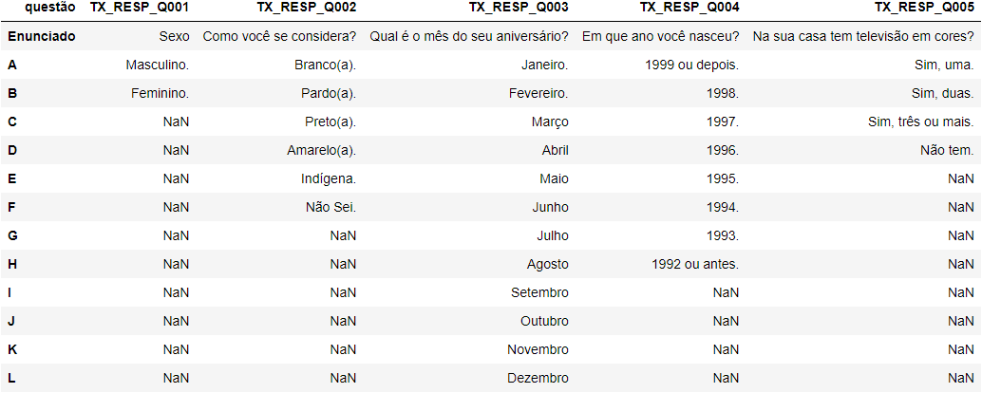

Data Cleaning - Dict_9th_Grade

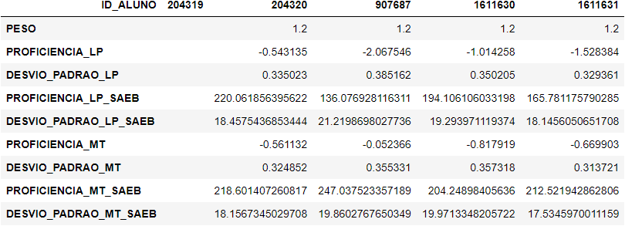

Data Cleaning - Grades_Cols_Head

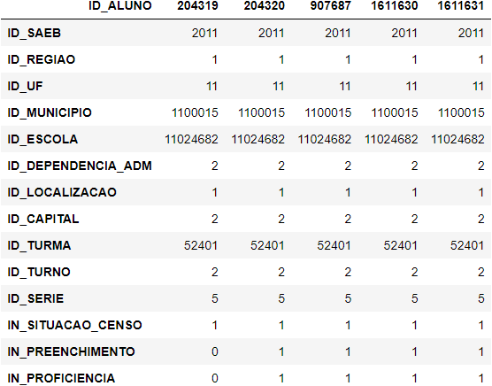

Data Cleaning - Grades_Ids_Table_Head

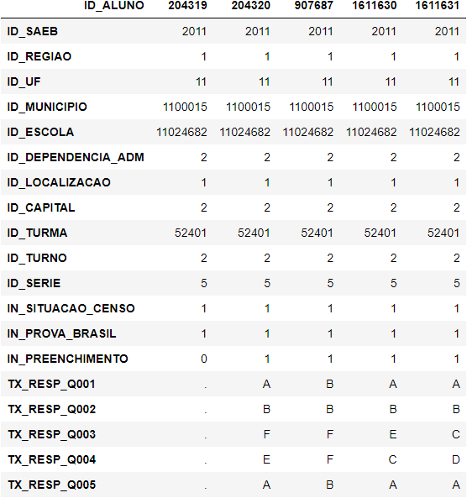

Data Cleaning - Main_Table_Head

**Data Transformation**

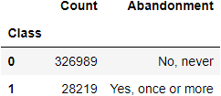

Data Transformation - Class_Count_Filtered

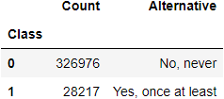

Data Transformation - Class_Count_Filtered_Grades

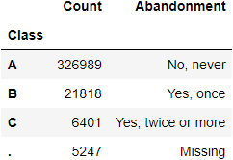

Data Transformation - Class_Count_Original

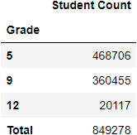

Data Transformation - Student_Count

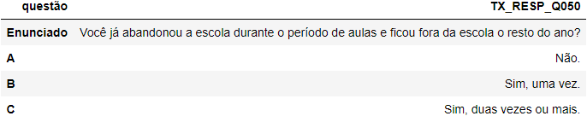

Data Transformation - Target_Variable_Info

**Evaluation**

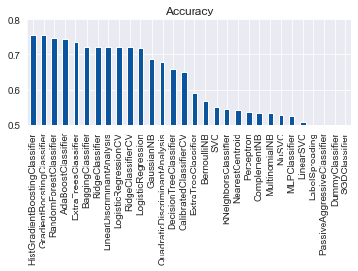

Evaluation - Classification_Comparison_Barplot

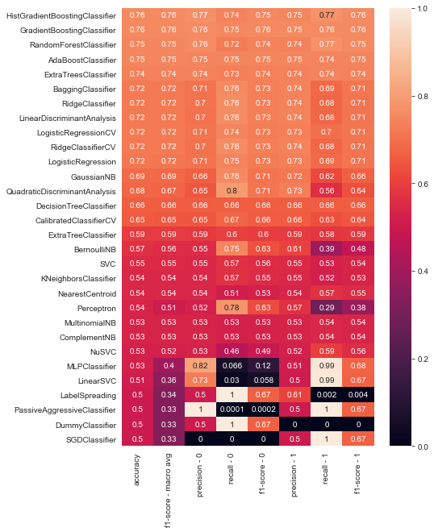

Evaluation - Classification_Comparison_Heatmap

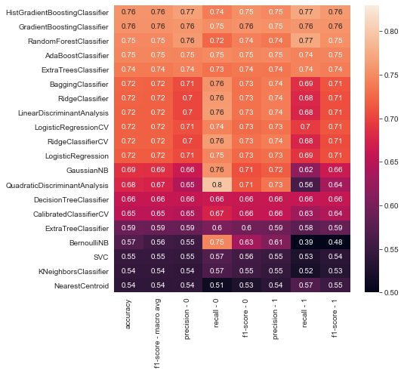

Evaluation - Classification_Comparison_Heatmap_head

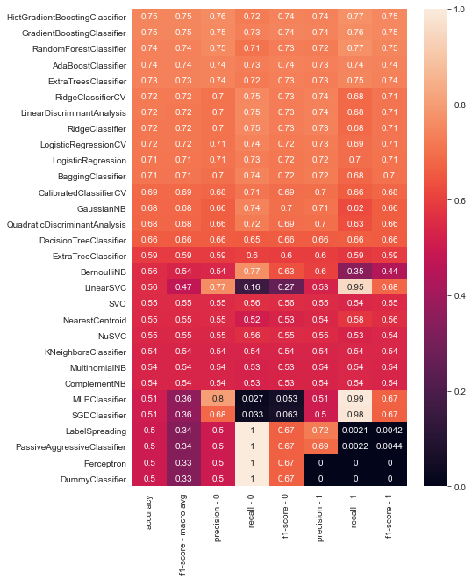

Evaluation - Model_Comparison_Heatmap

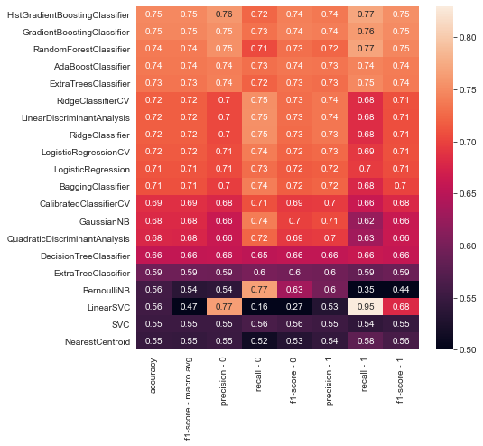

Evaluation - Model_Comparison_Heatmap_head

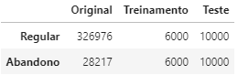

Evaluation - Model_Comparison_Sampling

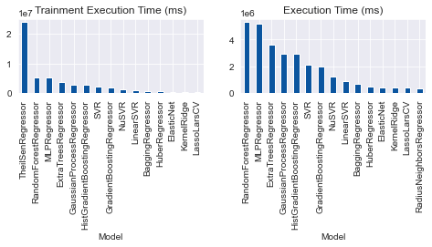

Evaluation - Regression - Execution Time

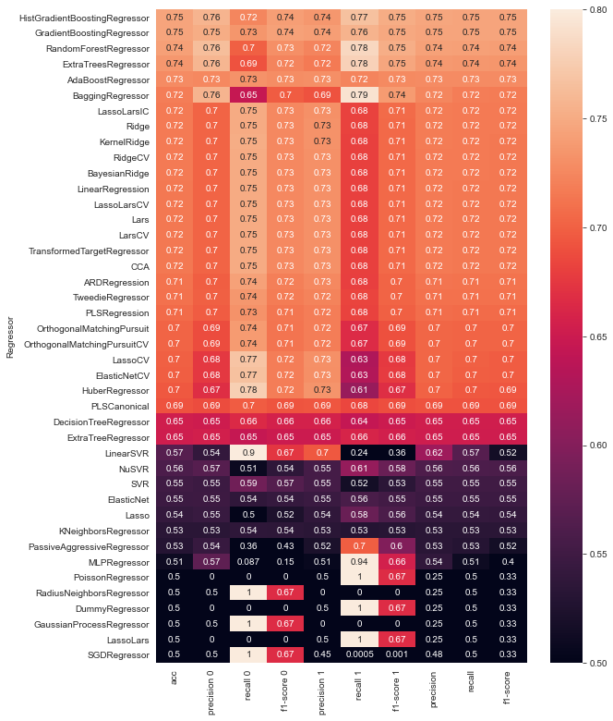

Evaluation - Regression_Comparison_Heatmap

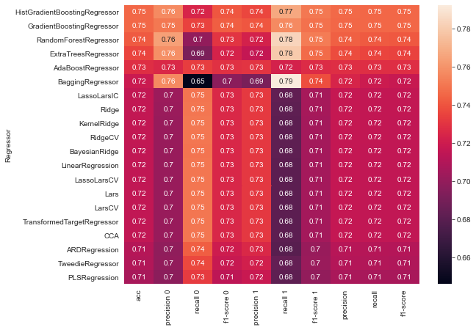

Evaluation - Regression_Comparison_Heatmap_head

**Evaluation**

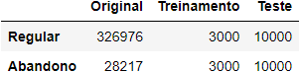

Evaluation - Sampling

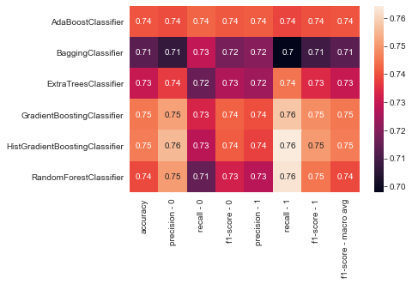

Model_Comparison_Heatmap

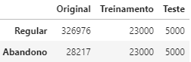

Optimization_Sampling

**Class Proportion Optimization**

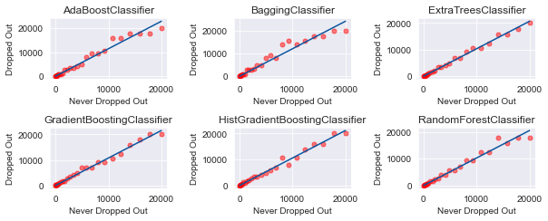

Class Proportion Optimization - 2D Regression

**Class Proportion Optimization Line Plots**

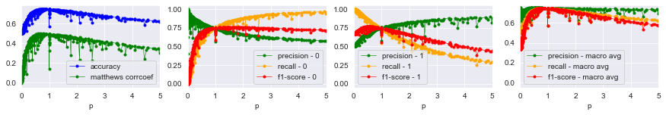

Line Plots - AdaBoostClassifier

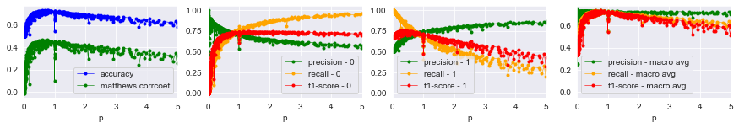

Line Plots - BaggingClassifier

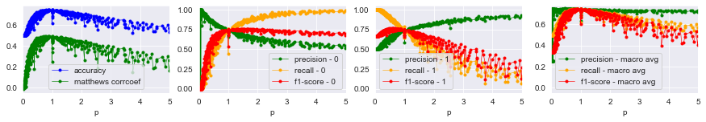

Line Plots - ExtraTreesClassifier

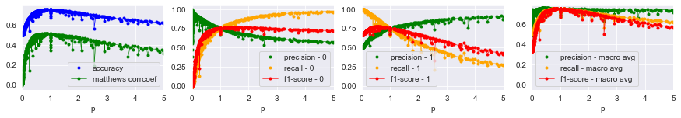

Line Plots - GradientBoostingClassifier

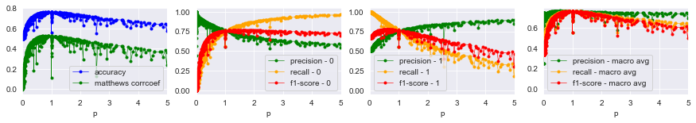

Line Plots - HistGradientBoostingClassifier

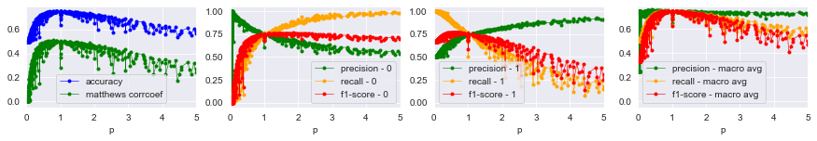

Line Plots - RandomForestClassifier

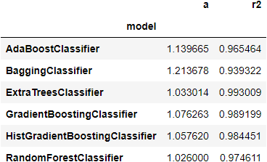

Optimal Class Proportions - Regression

**Class Proportion Optimization**

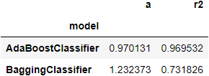

Class Proportion Optimization - Optimal Class Proportions - Regression

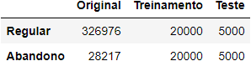

Class Proportion Optimization - Sampling

**Feature Importance**

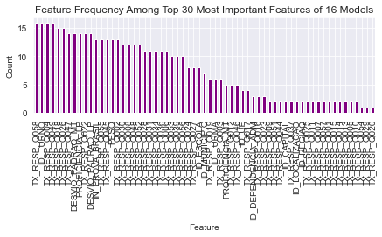

Feature Importance - Feature Frequency Barplot - Top 10



Feature Importance - Feature Frequency Barplot - Top 30

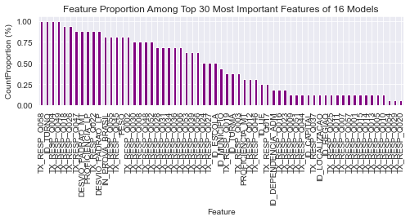

Feature Importance - Frequency Proportion Barplot - Top 10

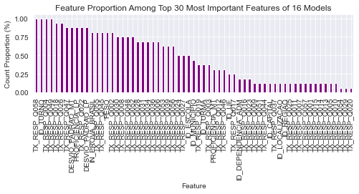

Feature Importance - Frequency Proportion Barplot - Top 30

**Feature Importance Per Model**

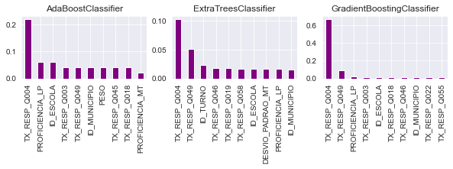

Per Model - Bar plots - 1

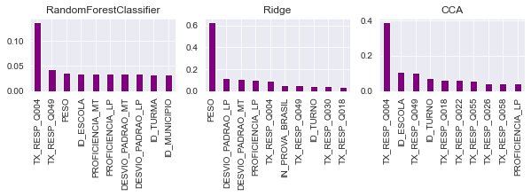

Per Model - Bar plots - 2

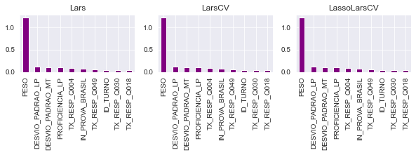

Per Model - Bar plots - 3

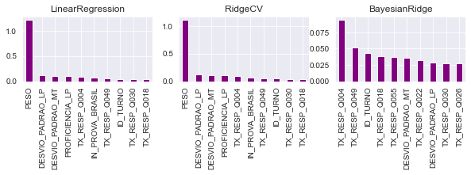

Per Model - Bar plots - 4

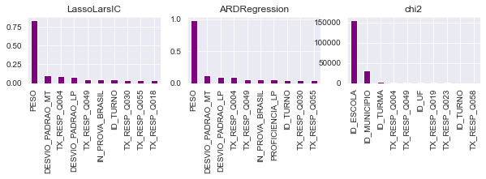

Per Model - Bar plots - 5

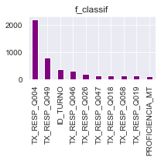

Per Model - Bar plots - 6

**Feature Importance Feature Proportion**

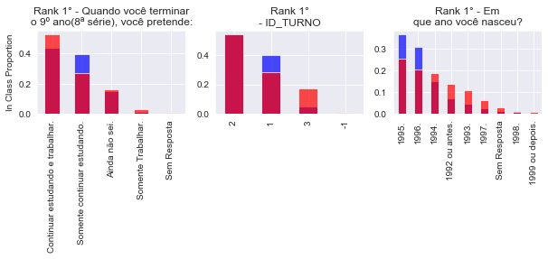

Feature Proportion - In Class - 1

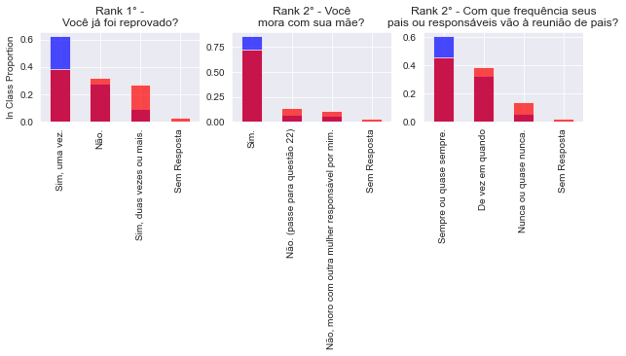

Feature Proportion - In Class - 2

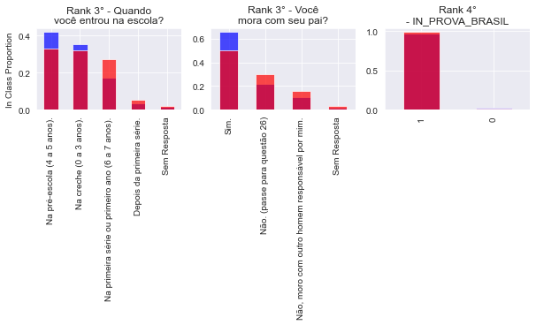

Feature Proportion - In Class - 3

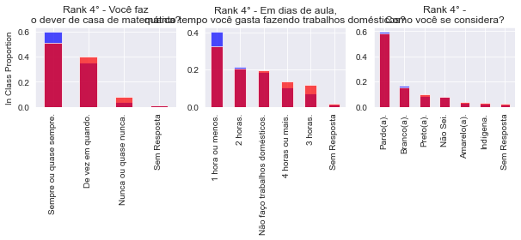

Feature Proportion - In Class - 4

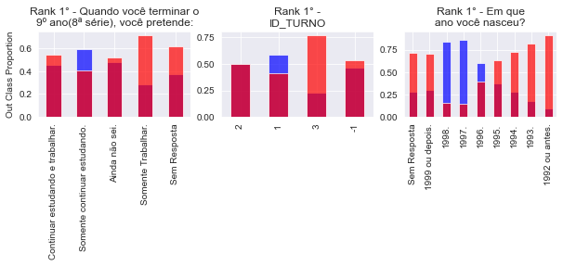

Feature Proportion - Out Class - 1

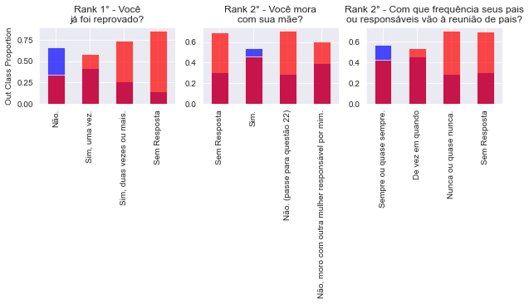

Feature Proportion - Out Class - 2

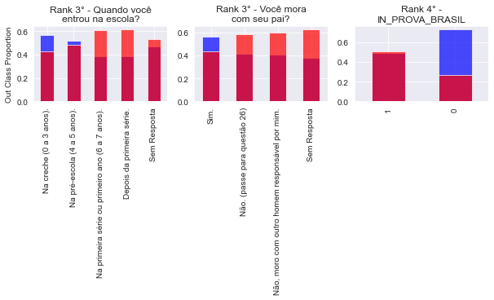

Feature Proportion - Out Class - 3

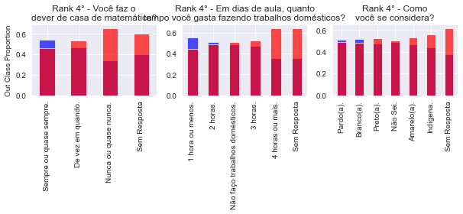

Feature Proportion - Out Class - 4

**Feature Importance**

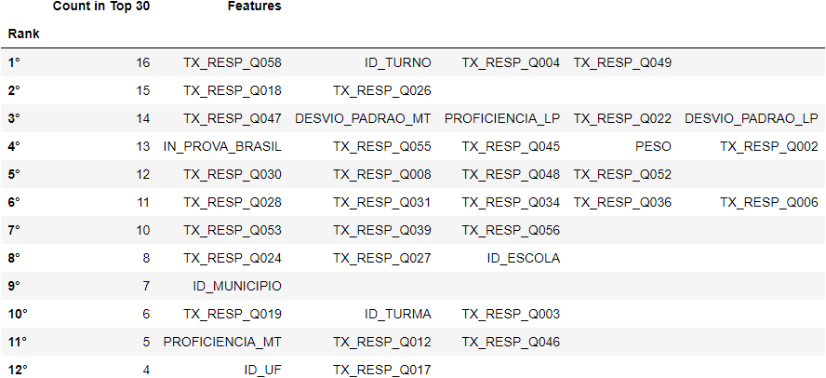

Feature Importance - Feature Rank Head

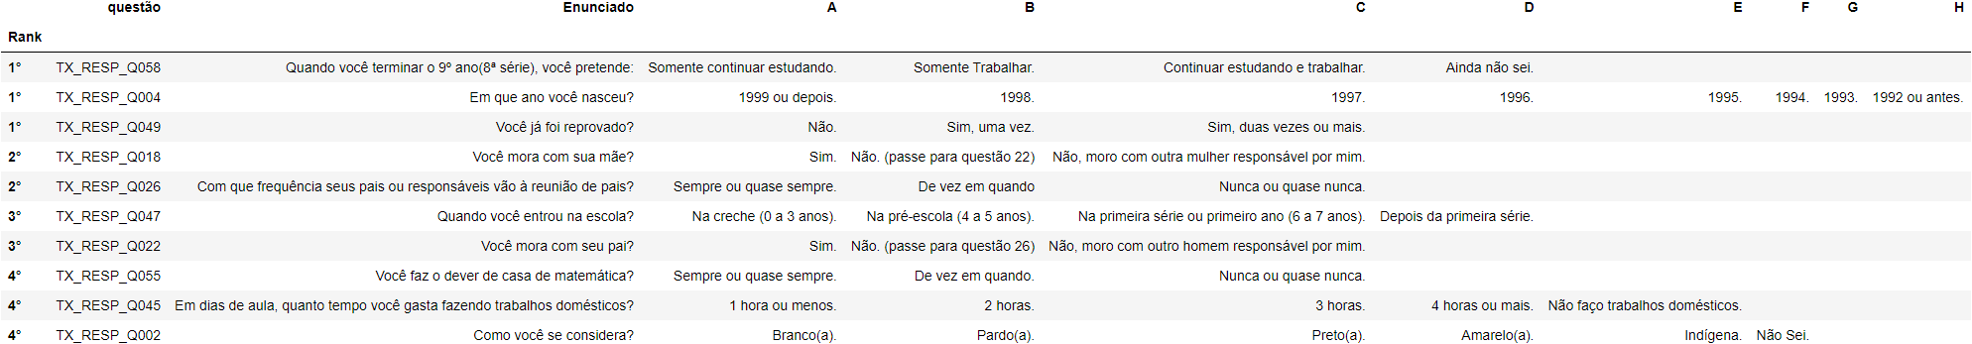

Feature Importance - Selected Questions